Instagram Comments Dataset Analysis Report

Intern Name: Harshitha S M
Organization: Alfido Tech
Domain: Data Science Internship

1. Introduction:
Instagram is one of the world's most popular social media platforms, enabling users to share photos, videos, stories, reels, and interact through comments. The objective of this project is to analyze Instagram comment data and identify user engagement patterns, hashtag usage, emoji usage, and commenting behavior.

2. Objective:
The main objectives of this project are:
1.Analyze Instagram comments data.
2.Identify active users.
3.Find the most commented photos.
4.Analyze emoji usage.
5.Study hashtag usage patterns.
6.Examine comment length distribution.
7.Visualize important insights using graphs.

3. Dataset Description:
The dataset contains Instagram comments information with the following attributes:
Column Name Description
id Unique Comment ID
comment Comment Text
User id User Identifier
Photo id Photo Identifier
created Timestamp Comment Creation Time
posted date Date Posted
emoji used Indicates Emoji Usage
Hashtags used count Number of Hashtags Used

Total Records: 7488
4. Tools and Technologies Used:
1.Python
2.Pandas
3.Matplotlib
4.Google Colab / Jupyter Notebook

5. Methodology:
Step 1: Data Loading:
The dataset was loaded using Pandas.
Step 2: Data Inspection:
1.Checked dataset dimensions.
2.Examined column names.
3.Identified missing values.
Step 3: Exploratory Data Analysis:
1. Emoji Usage Analysis
2.Hashtag Usage Analysis
3.User Activity Analysis
4. Photo Engagement Analysis
5. Comment Length Analysis
Step 4: Data Visualization:
Various graphs were created using Matplotlib.

6. Analysis Performed:
A. Emoji Usage Analysis
The dataset contains comments with and without emojis.
Purpose:
Understand user engagement.
Measure emoji adoption among users.
B. Hashtag Usage Analysis
Hashtags are important for content visibility.
Purpose:
Determine average hashtag usage.
Understand hashtag distribution.
C. Active User Analysis
Users with the highest number of comments were identified.
Purpose:
Find highly engaged users.
Measure user participation.
D. Most Commented Photos
Photos receiving the highest number of comments were identified.
Purpose:
Determine highly engaging posts.
Measure audience interaction.
E. Comment Length Analysis
Length of each comment was calculated.
Purpose:
Understand commenting behavior.
Measure engagement depth.

7. Results:
Key Findings:
1. The dataset contains 7488 comments.
2. Emoji usage is nearly balanced between comments containing emojis and those without emojis.
3. Hashtag usage varies from 0 to 6 hashtags.
4. Certain users are significantly more active than others.
5. Some photos receive substantially more comments than others.
6. Most comments are short and concise.
7. Hashtags and emojis contribute to higher engagement levels.

8. Visualizations:
The following visualizations were generated:
2.Hashtag Usage Distribution
3.Top 10 Active Users
4.Top 10 Most Commented Photos
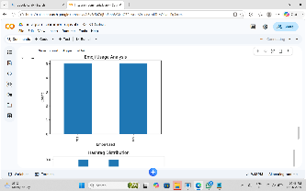
5.Comment Length Distribution
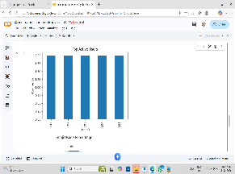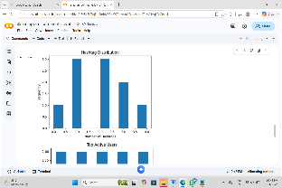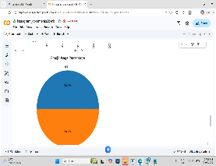

9. Conclusion:
This project successfully analyzed Instagram comments data and provided insights into user engagement patterns. The analysis revealed trends in emoji usage, hashtag utilization, active users, and photo popularity. Such insights can help businesses, influencers, and marketers better understand audience interaction and optimize their social media strategies.

10.Future Scope:
1.Future improvements may include:
2.Sentiment Analysis of comments.
3.User Behavior Prediction.
4.Comment Classification.
5.Engagement Prediction Models.
6.Dashboard Development using Power BI or Tableau.

11. References:
1.Python Documentation
2.Pandas Documentation
3.Matplotlib Documentation
4.Instagram Dataset from Kaggle

GitHub Repository:
GitHub Link: https://github.com/harshithagowda9867-source/Alfido-tech-intership

Notebook Link:
Colab/Jupyter Link: _https://colab.research.google.com/drive/1Fs2FGv6URVeJe9aJdyGzh8qFCQGcDjbc#scrollTo=HVM-mDbg3ojj&line=1&uniqifier=1

